Alice in Wonderland lead image
Alice falls down the rabbit hole as playing cards fly around her, she reaches up to the sky

The Art of Becoming

Autumn 2025

Lincoln Arts Centre

Contextualisation & Note from Ben Anderson

This autumn, we present The Art of Becoming, a season that explores the many stages of life: finding your voice, growing up, growing older, and discovering who you are along the way.

Greater Lincolnshire has one of the UK’s most ageing populations, while Lincoln itself is driven by a fast-growing younger generation. This contrast brings both challenges and opportunities. The Art of Becoming responds with a programme of original commissions, artworks and performances reflecting this change.

We open with the **Social Prescribing Conference (16 October)**, exploring how creative activity supports wellbeing, particularly for young people in transition. That same day, Associate Artists **Zest Theatre**  present  **Soundboard (16 October)**, a fast-paced, interactive new show. Part chat show, part game, part live performance, commissioned by Lincoln Arts Centre.

Later in the month, **Cracking Slate** brings **Lose the Path, Find Your Way (24 October)**, a modern fairy tale-meets-choose-your-own-adventure for families about making choices and finding direction.

A season highlight is **Meet the Hatter (31 October – 1 November)** from **Joss Arnott Dance**—a magical multimedia performance reimagining the Mad Hatter from Alice in Wonderland. Aimed at ages 5+, the show combines live dance and digital technology and launches a national tour in Autumn 2025, coinciding with the company’s 15th anniversary.

We’re also thrilled to welcome back the **Lincoln Book Festival (2–5 October)**, with the Arts Centre once again serving as its creative hub. As part of the **Climate Action Festival**, **Future Perspectives (6 November)** returns to ask whether technology can help the creative industries go green. Plus this season sees the launch of **National Theatre Live** screenings, bringing world-class performances to Lincoln audiences.

The ever-popular **Sh!t-faced Shakespeare®** returns on **14 November** with a raucous, intoxicated take on **Hamlet**—a tale of youth, privilege, and self-discovery.

From **27-29 November**, our now famous, **Science Live On Stage** returns this time, with a Ready, Set Go! Theme exploring the science behind sport, aimed at children and young people via our Every Child scheme.

We close the year with a festive treat: **Alice in Wonderland (11–21 December)**, a magical Christmas production from **Lincoln School of Creative Arts**, following last year’s hit The Snow Queen. Expect an unforgettable journey down the rabbit hole for all the family.

Ben Anderson

**Creative and Executive Director, Lincoln Arts Centre**

**We know every child is creative but not every child gets access to great cultural experiences, and we want to change that.**

If you can add a donation to your ticket to support our Every Child appeal, you would be supporting that change.

Join the conversation

[www.lincolnartscentre.co.uk](http://www.lincolnartscentre.co.uk/)

01522837600

@lincsartscentre #ArtofBecoming

Café Bar

Our Café Bar is open 8.30am - 6.00pm* every weekday and one hour prior to events.

*Opening times may vary due to changes in seasonal demand and academic timetable. For the latest opening times, check our website.

Please note that the University of Lincoln is a cash free organisation. Payments can be made by debit or credit card only at our Café Bar.

Live Pass

If you’re aged 16-30 or a student of any age, don’t forget to sign up to **Live Pass**, our free membership offering a range of discounts on shows and in our cafe, plus exclusive events and a network of like-minded creatives.

Keep an eye out for the **Live Pass Discounts** or **Live Pass Creative Meet Up** on selected events this season; this means there’s exclusive discounts or pre-performance social events for Live Pass members.

Sign up online or at our box office.

We’re Open to Ideas

The best way to start a conversation about working together is by making us aware of your work through our Open to Ideas open submission.

Our priority is nurturing the next generation of artists or artistic ideas. Often that means we are interested in artistic work that tests the boundaries of form, is challenging or is helping us to develop new audiences. Please read our Open to Ideas policy before submitting.

You can submit online via our website!

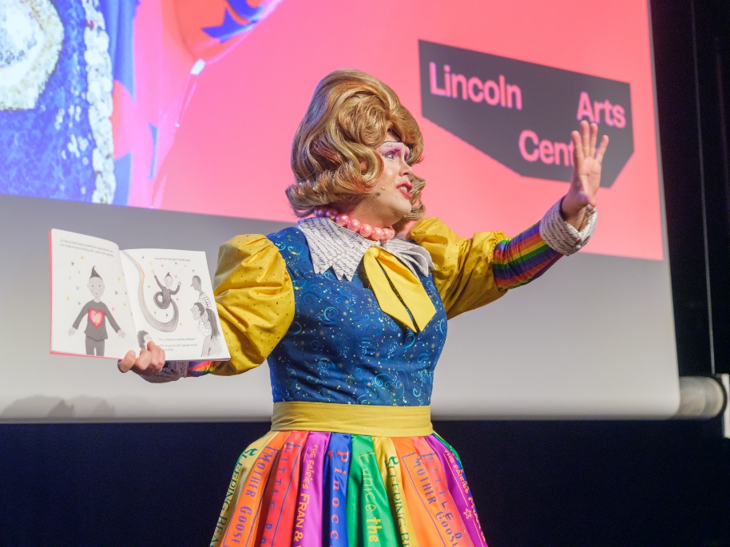Photo Credit: Richard Hall

Lincoln Book Festival | 2 - 5 October

Lincoln City / Workshops & Talks

**Live Pass Creative Meet Up**

This year, Lincoln Book Festival’s diverse programme ranges from inspiring author events, workshops, trails, performances and family-friendly activities to readings, competitions, open mic events and panel discussions where all ages can get creative and be inspired by words.

The festival’s annual creative writing challenge invites budding authors to produce their own 50 word short and enter our ever-popular Flash Fiction Competition. This year’s theme has been revealed as “heroes and villains”, drawing inspiration from milestones in British history and literature.

Keep your eyes peeled for programme announcements at [lincolnbookfestival.org](http://lincolnbookfestival.org/)

**Supported by Lincoln Arts Centre as the festival hub and principal partner.**

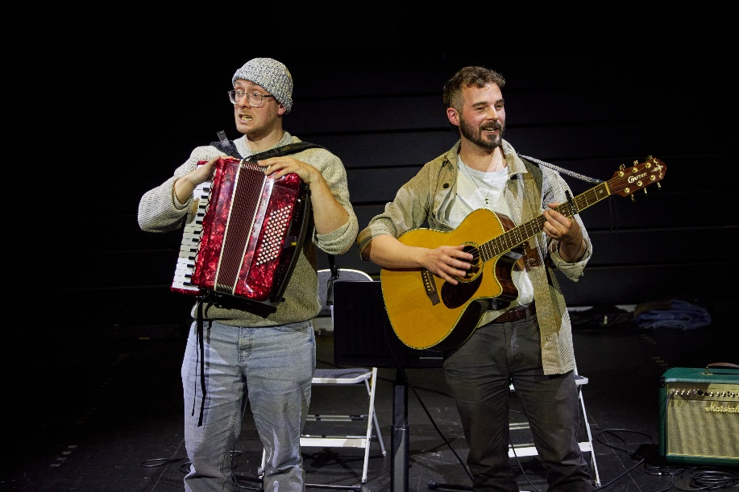Photo credit: Phil Crow

Lincoln Arts Centre presents

Demo | 2 & 30 October

Lincoln Arts Centre / Mixed Arts

Be part of developing the next big thing!

Demo is your chance to see the best new artistic ideas tested out in front of an audience, often for the very first time.

Offering a selection of new work from the most exciting artists both regionally & nationally, this event encourages critical discourse in a relaxed and supportive environment.

Everyone is welcome.

Standard / £7

Live Pass / £5



*National Theatre Live presents*

Inter Alia | 10 October / 7pm

A new play by Suzie Miller

Auditorium / Film

Oscar-nominated Rosamund Pike (Gone Girl, Saltburn) is Jessica in the much-anticipated next play from the team behind Prima Facie.

Jessica Parks is a smart Crown Court Judge at the top of her career. Behind the robe, she is a karaoke fiend, a loving wife and a supportive parent. When an event threatens to throw her life completely off balance, can she hold her family upright?

Writer Suzie Miller and director Justin Martin reunite following their global phenomenon Prima Facie, with this searing examination of modern motherhood and masculinity.

Age guidance: 14+

Standard / £18

Live Pass / £15

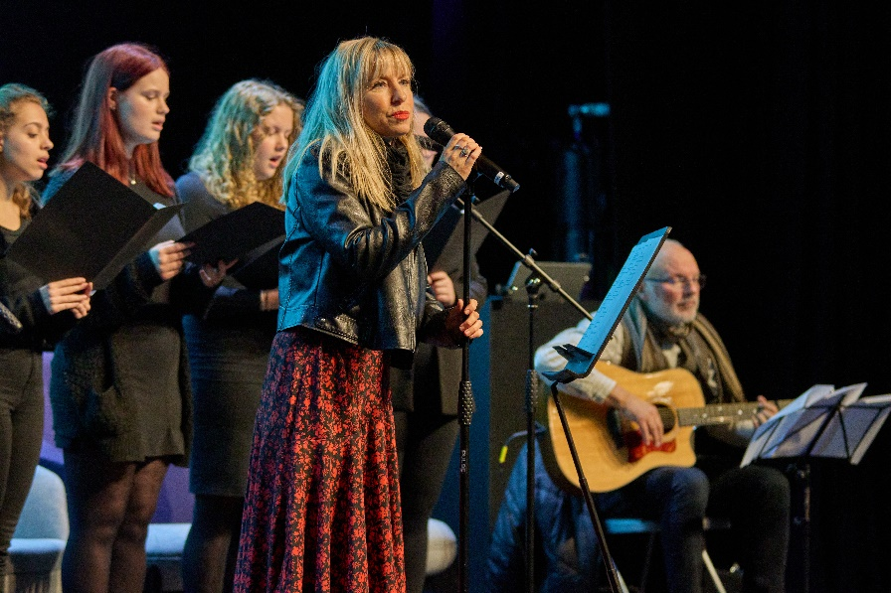Photo Credit: Richard Hall

Lincoln Arts Centre presents

Prescribing Change: Young People and Social Prescribing | 16 October / 10am

Auditorium / Conference

A daylong event focused on social prescribing, with a spotlight on young people’s voices and their mental health and wellbeing.

The event isn't just about reflecting. The afternoon will focus on ambitious bid writing and collaborative project development, creating space for partners to come together to respond to recent funding challenges with renewed energy and shared purpose.

What to expect:

* Young people’s insights and lived experience
* Midlands case studies on effective social prescribing models
* Creative performances (indoor and outdoor)
* Honest conversations and peer-to-peer support
* Space to build partnerships and shape collective bids for the future

Whether you're a creative health practitioner, policy maker, community leader, or young person shaping your own path, this is a space for you.

Free Tickets / Booking Required



Soundboard | 16 October / Various Times

Campus / Participatory

A show shaped by you in real-time.

Part chat show, part game, part live performance—Sound Board is packed with quick-fire debates, playful challenges, and surprising moments of honesty. No two shows are the same, but every one is full of big ideas, bold opinions, and unexpected moments that unfold all around you.

Pop on a pair of headphones, listen in, and see where it takes you. No scripts. No barriers. No filters. Just real voices, big ideas, and the energy of right now.

Age Guidance: 11-18

Free Tickets

**Intergrated Audio Description**

**Touch Tours Available**

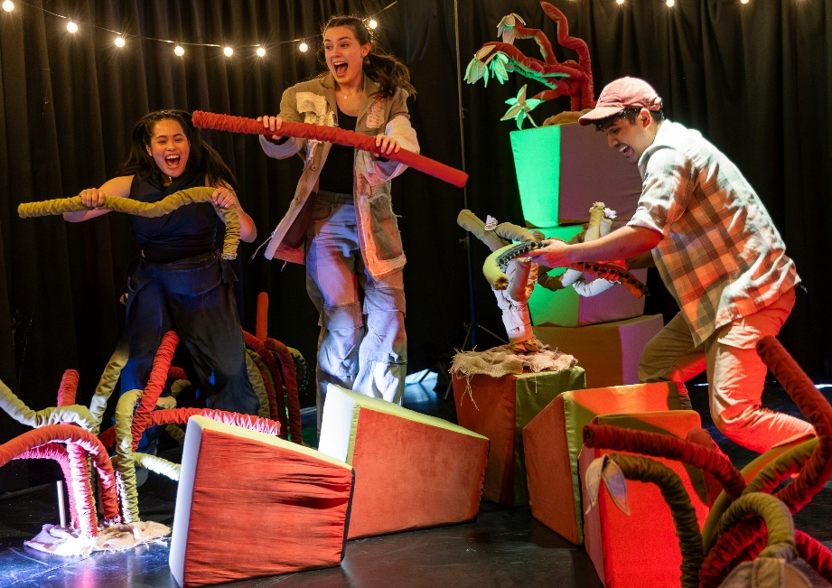Photo Credit: Ellie Jurttz

Cracking Slate Presents

Lose the Path, Find Your Way | 24 October / 11am & 3pm

Auditorium / Family

Ever been well and truly lost in the middle of a forest with no idea how to get home? Sam is, and he can't shake the feeling he’s being followed.

As Sam searches for the right path he stumbles across Akir and Kiyomi, who offer to show him the way back.

Like a Choose Your Own Adventure book, brought to life with enchanting movement, music and puppetry, Lose the Path, Find Your Way is a new participatory show for children aged 9-11 and their families about home, making your own choices and what it means to be a friend.

Age Guidance 9 – 11

Child / £8

Adult / £5

Family (2 adult, 2 children) / £20

**Touch Tours Available**

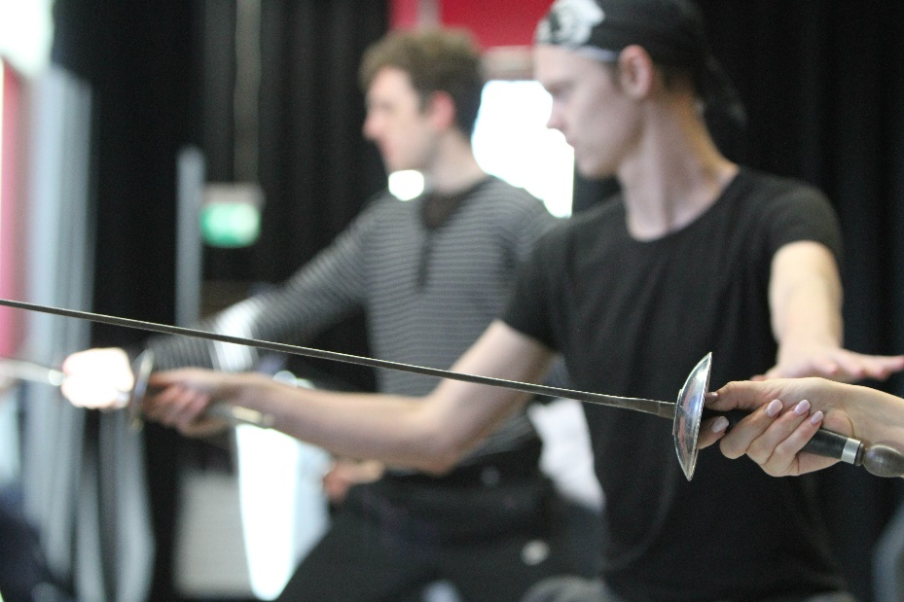

Stage Combat | October 24 – 26

Studio / Workshop

A two-and-a-half-day intensive sword course designed for people with no or little experience all the way up to those with industry recognised qualifications in stage combat. We will be doing an introduction to Single Sword, the foundation of stage combat sword work. For intermediate and Advanced, 18th Century Smallsword.

Standard / £110

Live Pass /£80

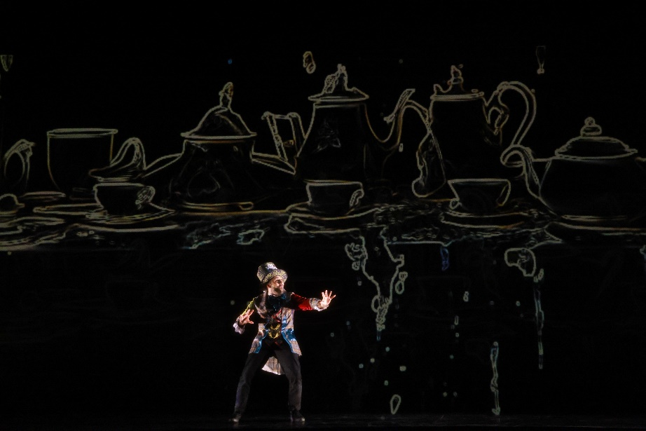

Joss Arnott Dance Presents

Meet the Hatter | 31 October & 1 November

Auditorium / Dance

Curiouser and curiouser…

Meet the Hatter is a brand-new, cinematic dance and multimedia production by one of the UK’s leading contemporary dance companies, Joss Arnott Dance, featuring a new story of the iconic Hatter that reveals his longing for companionship.

To escape the sense of isolation, the Hatter uses the power of his imagination to create his own magical and epic version of Wonderland shown through breathtaking digital projections and animation - but what adventures lie ahead?

Age Guidance: 5+

Child / £10

Adult / £15

Live Pass / £12

Family / £40 (2 Adults, 2 Children)

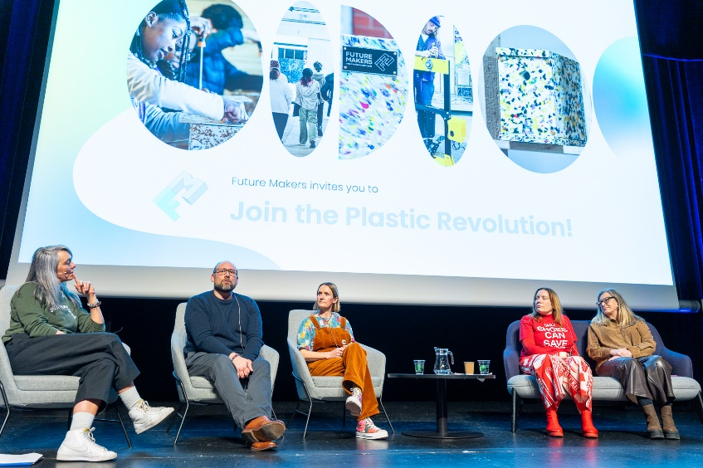Photo Credit: Richard Hall

Barbican Creative Hub Presents

Future Perspectives: Green Wash or Gamechanger? | 6 November / 10am

Auditorium / Conference

Showcasing sustainable innovation in the creative industries

Coinciding with the university’s Climate Impact Festival this event highlights how creative industry businesses are using technology to drive real environmental change.

From international exemplars to local pioneers, we’ll showcase the people and projects rethinking materials, methods, and mindsets — and using tech to make their practices cleaner, greener, and more future-facing. Expect bold ideas, honest conversations, and practical inspiration from those turning ambition into action — without the greenwash.

Free Tickets / Booking Required



Sh!tfaced Shakespeare Presents

Hamlet | 14 November / 7.30pm

Auditorium / Theatre

Sh!t-faced Shakespeare ® ️ are excited to once again drunkenly stomp all over the greatest dramatic work ever committed to page in the English language: the story of a privileged whiny lad who goes a bit bonkers and does some stabbings.

Age Guidance: 16+

Standard / £26

Live Pass / £23

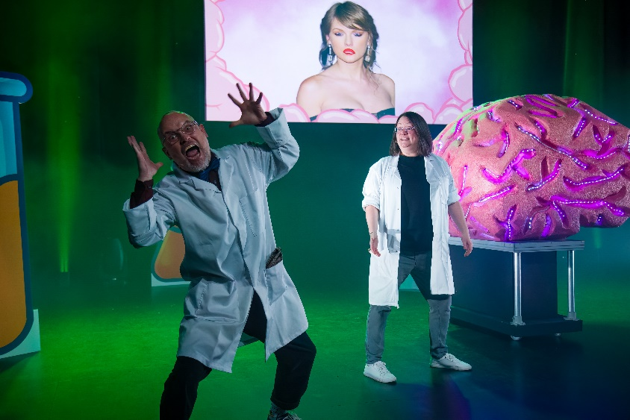Photo Credit: Dominic Clayton

Lincoln Arts Centre and University of Lincoln Presents

Science Live-on-Stage: Get Set, Go! | 27 – 29 November / Various times

Get ready for experiments of great magnitude, reactions of skillful aptitude, and a lecture that thinks outside the Bunsen Burner! Science Live-On-Stage has the perfect mix of Science, Performance, Media and Tech to create the perfect reaction.

This year, discover how taking part in sport can help you inside and out! In this action-packed show we will dive into the amazing sports science that makes you healthier, faster, stronger, while you smile more and make new friends along the way.

Science Live-on-Stage will give you and your little (or not so little) ones the opportunity to learn and have fun in one of the top 20 Universities in the UK for Biomedical Sciences, and the top 30 in the UK for Biological Sciences, as reported by Complete University Guide.

Age Guidance: 7+

Standard / £5

Child / £7

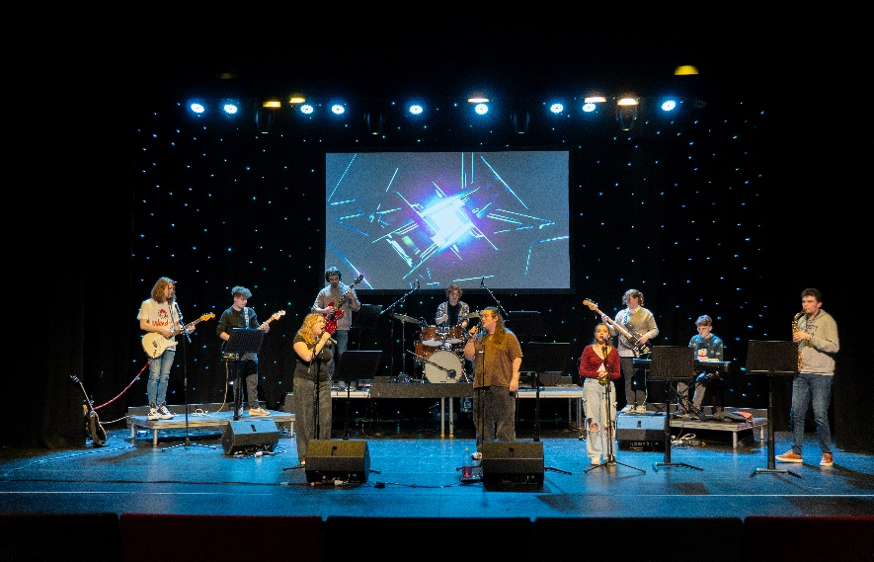Photo Credit: Matthew Luk

Lincoln School of Creative Arts Presents

BA Music Winter Showcase | 1-3 December / 6pm

Auditorium / Music

Join student performers from the University of Lincoln’s Music degree programme for three evenings of music from across genres and eras.

* Monday 1 December – instrumental, choral and folk music in a relaxed setting
* Tuesday 2 December – a mix of music including small groups and soloists
* Wednesday 3 December - an eclectic mix of pop music

Suitable for all ages.

Standard / £3

Alice in Wonderland lead image
Alice falls down the rabbit hole as playing cards fly around her, she reaches up to the skyPhoto Credit: Phil Crow

Lincoln School of Creative Arts and Lincoln Arts Centre presents

Alice in Wonderland | 11 – 21 December / Various Times

Auditorium / Theatre

Off we go down the rabbit hole! Follow the brave and wildly curious Alice as she chases an enigmatic White Rabbit deep into the captivating world of Wonderland — a place alive and buzzing with hilarious, nonsensical imagination, and where anything and everything is completely improbable but never impossible!

This brand-new stage interpretation is a playful, vibrant, visual feast that gets ever stranger and more mysterious with every strange, mysterious encounter… Expect laughter, vivid imagery and theatrical thrills in this classic tale reimagined: the latest Christmas co-production between Lincoln Arts Centre and Lincoln School of Creative Arts. A magical family treat!

Age guidance: 8+

Tickets from £10, check online for ticket pricing

Access

We offer a wide range of facilities to ensure that you have a comfortable and enjoyable experience with us: The Box Office, Café Bar and Auditorium are all ground floor accessible. There is a lift to provide access to the first floor Balcony and Studios 1, 2, 3 and X and on each floor is an accessible toilet.

The Box Office desk is a short distance from the main entrance. Part of our Box Office desk is a lower level for easy access.

### **Seating and the Main Auditorium**

The auditorium has spaces available for wheelchairs – companions can get a ticket free of charge. These designated spaces are located on the ground floor of the auditorium and gives guests plenty of space to sit comfortably. Should you wish to reserve a wheelchair space, please contact the Box Office on 01522 837600

Our auditorium seating is tiered, except the seating on Row A. All other seating is only accessible via steps. Please contact our Box Office if you require accessible step-free seating.

The auditorium is equipped with an induction loop system. If you require access to this, please inform the Box Office staff.

Assistance Dogs are welcome in all areas of the building and we will happily look after your dog whilst you enjoy the performance.

### **Parking**

The university carpark has parking spaces available to Blue Badge Holders.

**How do I book an Essential Companion ticket?**

You can book an essential companion or carer ticket by calling our Box Office on 01522 837600 during our opening hours (Mon-Fri, 10am - 4pm) and a member of our Front of House team will process your booking.

If we’re not open, or you’ve been unable to leave a message, then please email us via [enquiries@lincolnartscentre.co.uk](mailto:enquiries@lincolnartscentre.co.uk) or fill in our contact form on our website. We will then contact you within two working days.

**Familiarisation Visits**

We are happy to show you around prior to your visit and give you a tour of our wonderful spaces at a quieter time in the venue to ensure you have all the information you need. Alternatively, you can experience a digital orientation of the building on our website.

How to Book

Box Office Opening Hours: Monday – Friday 10-4 and one hour prior to events.

01522837600

**Booking Online**

You can book your tickets online through our website at <https://lincolnartscentre.co.uk/whats-on/>

If you can’t find the event that you’re looking for on the What’s On page, you can search for it using the filters or the search bar. Once you’ve found the event, click the Book Now button to purchase your tickets.

If you have an online account with us already, you’ll be able to log in. If not, you’ll need to set one up. Please be aware that the email address your account is linked to is the one that we will use to send your order confirmation and e-tickets.

**Booking in Person**

You can book your tickets directly from our Box Office. Pop into the venue during our opening hours and a member of our Front of House team will be more than happy to process your order.

The University of Lincoln is a cash free organisation. Payments can be made by debit or credit card only.

**Booking Over the Phone**

To book your tickets over the phone, simply call us on 01522 837600 during our regular opening hours. Our Box Office opens an hour before the start of an event, tickets are available to purchase over the phone during this time.

You can also use this number to contact us if you have any questions or queries regarding events, tickets, venue access, etc.

If you are having difficulty getting through on the phone, we might just be busy! If so, please either leave us a voicemail clearly stating your name and contact telephone number, fill in our [contact form](https://lincolnartscentre.co.uk/get-in-touch/), or try calling again in a couple of minutes.

**Babes in Arms Policy**

All babes in arms under 18 months go free, however you will still need to book them a ticket. You can call us to do this.

**University of Lincoln Staff**

Staff can get access to staff discount on selected shows. Discount varies per event.

How to Find Us

Based in the heart of University of Lincoln’s striking city centre campus, Lincoln Arts Centre is well connected with excellent public transport links both locally and nationally.

**Location**

Lincoln Arts Centre, Brayford Pool, University of, Lincoln LN6 7TS (located next to the Engine Shed)

**Getting Here**

The city of Lincoln is 40 miles east of Nottingham on the A46 and 40 miles south of the Humber Bridge on the A15. Follow the signs for University of Lincoln and Brayford Pool. SAT NAV/Google Maps/Apple Maps users, please use our LN6 7DQ postcode.

**Getting here by public transport**

Lincoln Arts Centre is a short 10 minutes’ walk from Lincoln Central Station and Lincoln City Bus Station.

A number of services run close to the venue. For details of services call Stagecoach on 0845 605 0605 or Traveline on 0871 200 2233

The Art of Becoming

Calendar September – October 2025

|  |  |
| --- | --- |
| October 2 - 5  **Lincoln Book Festival**  Lincoln City / Workshops & Talks    October 2 & 30  **Demo**  Lincoln Arts Centre / Mixed Arts    October 10  **Inter Alia**  Auditorium / Film    October 16  **Prescribing Change: Young People and Social Prescribing**  Auditorium / Conference    October 16  **Soundboard**  Campus / Participatory    October 24  **Lose the Path, Find Your Way** Auditorium / Family    October 24 - 26  **Stage Combat**  Studio / Workshop | October 31 & November 1  **Meet the Hatter**  Auditorium / Dance    November 6  **Future Perspectives: Green Wash or Gamechanger?**  Auditorium / Conference    November 14  **Hamlet**  Auditorium / Theatre    November 27 - 29  **Science Live on Stage: Get Set, Go!** Auditorium / Theatre    December 1 - 3  **BA Music Winter Showcase**  Auditorium / Music    December 11 - 21  **Alice in Wonderland**  Auditorium / Theatre |